REPORT ON LICENSE PLATE RECOGNITION

PRATESI LEONARDO MATRICOLA 1214388

In this report I will explain the process in the making of the license plate algorithm in C++ and Python.

All the process was liberally inspired by the book “Mastering OpenCV”.

All the code and image used are available on GitHub at <https://github.com/leopra/LicensePlateRecognition>

The process can be divided in 3 STEPS:

* License Plate Recognition
* Single Digits Recognition
* Character Recogniton

I will show the process on this partcular image of a BMW M5 back. The process of tuning the parameters was evaluated on the six given images.

In the coding process no C++ classes or headers where used to simplify the refactoring.

At first I apply a Gaussian Blur to reduce the noise of the image with a 5by5 kernel (other sizes were tested but this perfomed better). Then a Sobel filter is applied to emphasize vertical lines as a plate by having digits should have a lot of them.

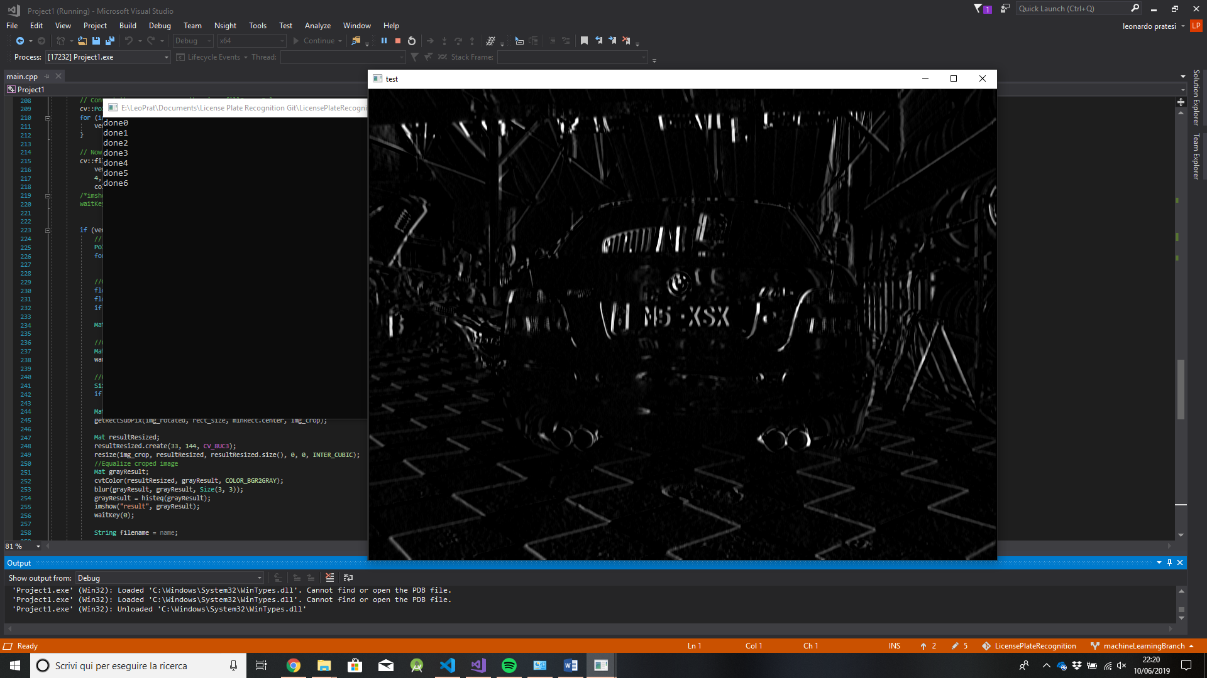A threshold filter is then applied so a rectangular dilate operator with size 20x3 can be executed with the purpose of linking together the vertical lines of the Sobel algorithm representing the plate’s characters.

Figura Sobel filter

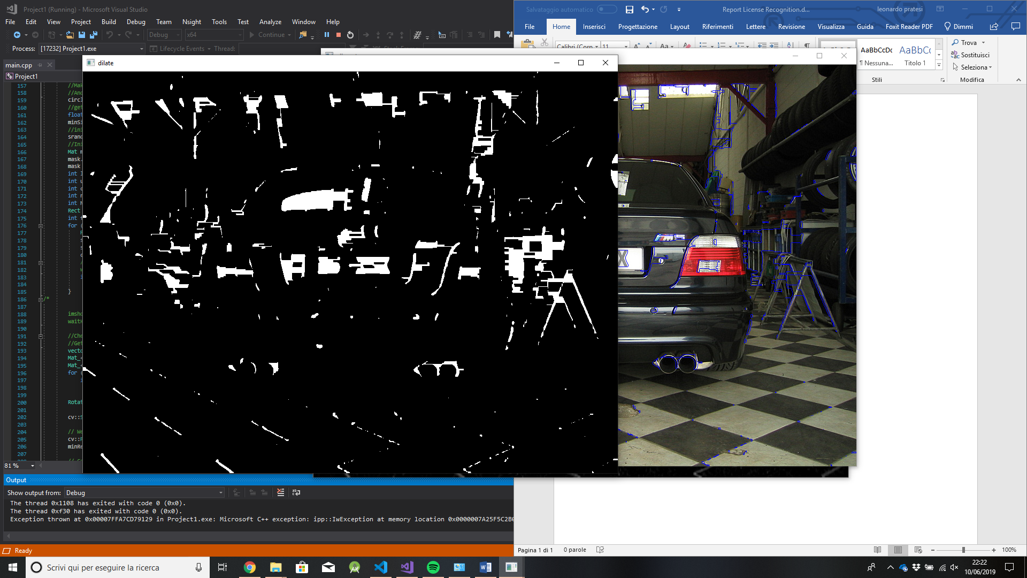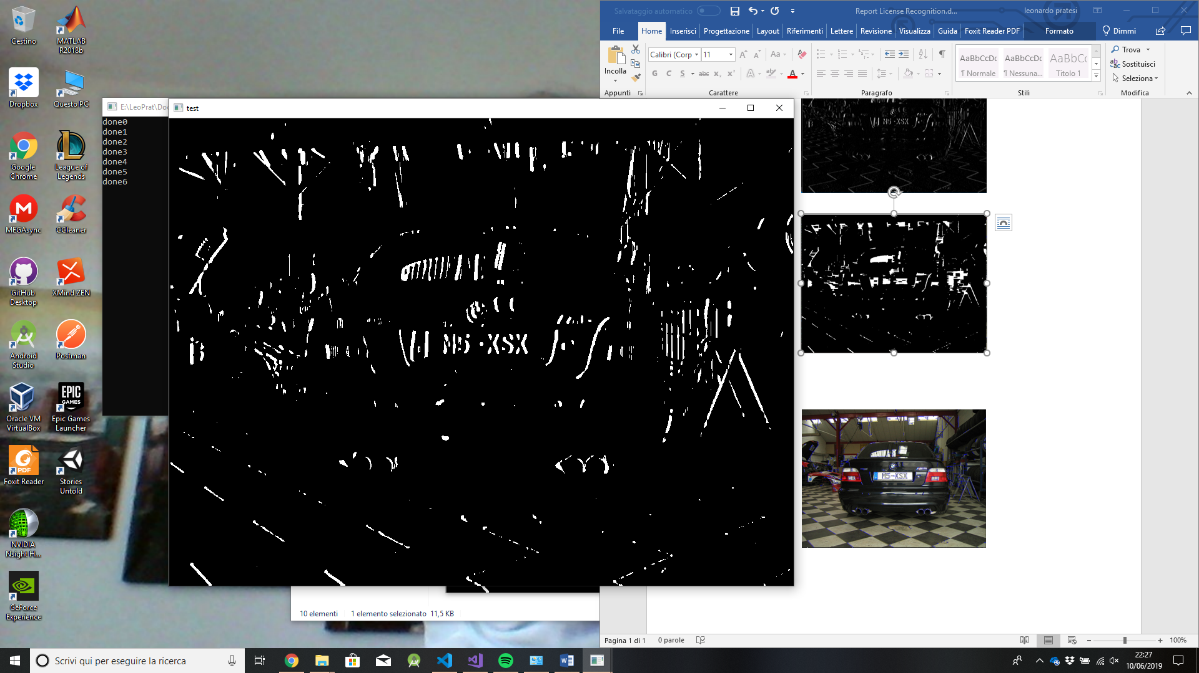

Figura 3 Dilate filter

Figura threshold filter

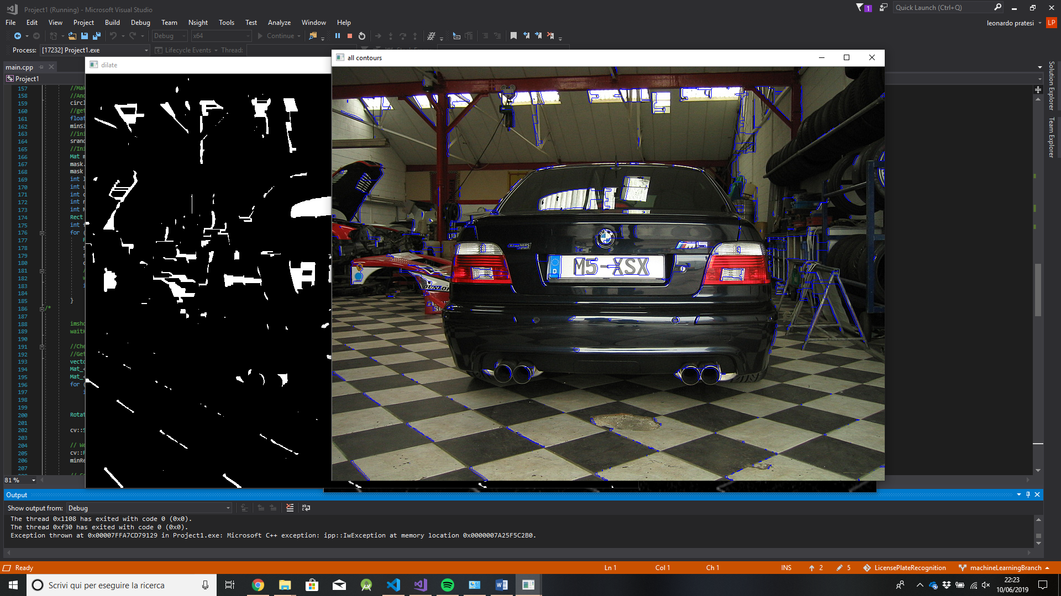The function findContours is then applied.

Figura 4 find contours